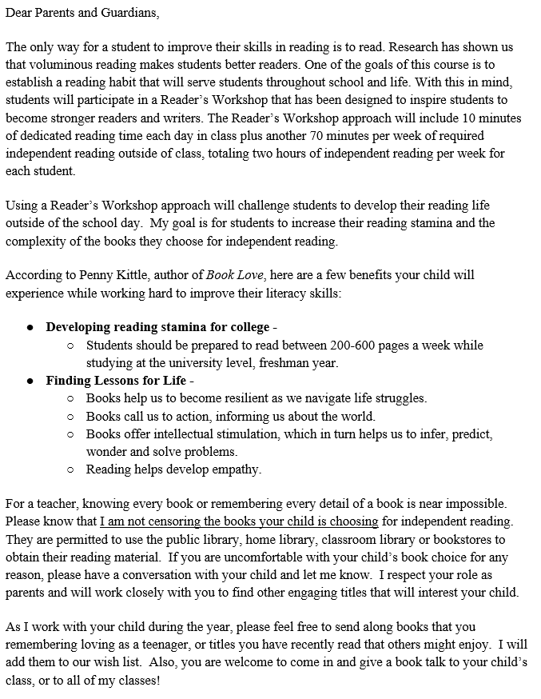
James McCaffrey
Trumbull Public Schools
Trumbull High School
English Department
jmccaffr@trumbullps.org
@McCaffTHS
@THSReadRev
www.thsreadingrevolutionC31.weebly.com

